1. 
2. 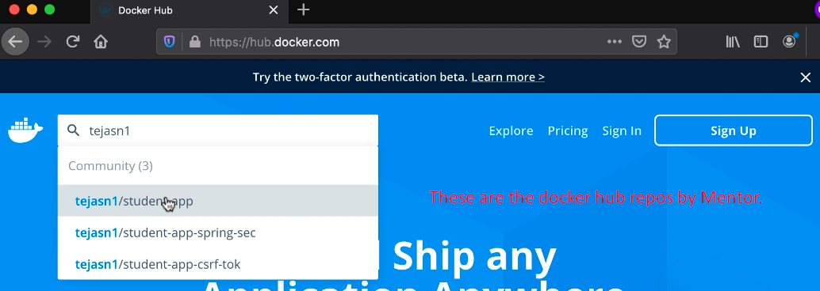
3. 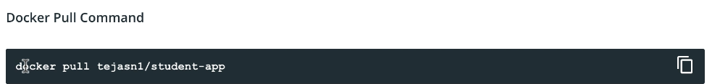
4. 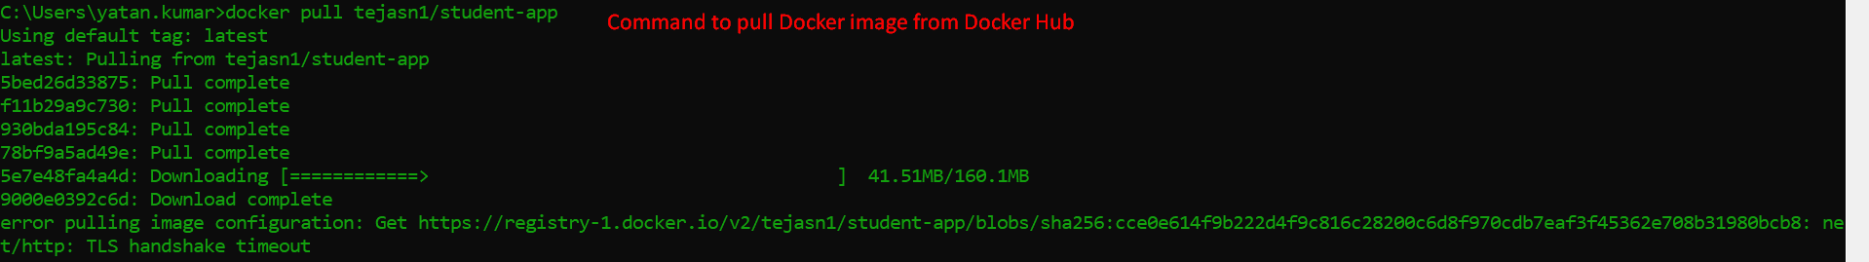
5. 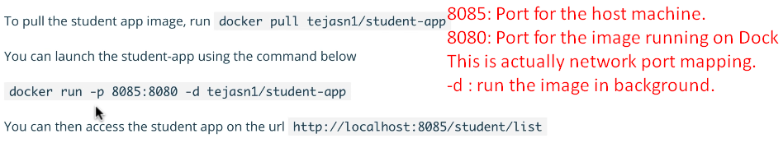
6. 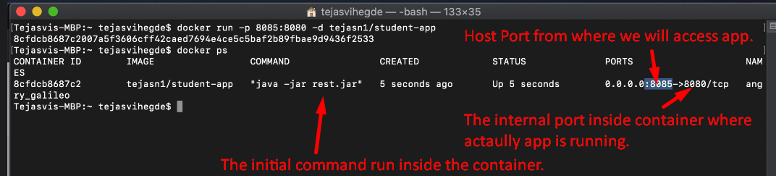
7. Running app on different port  
   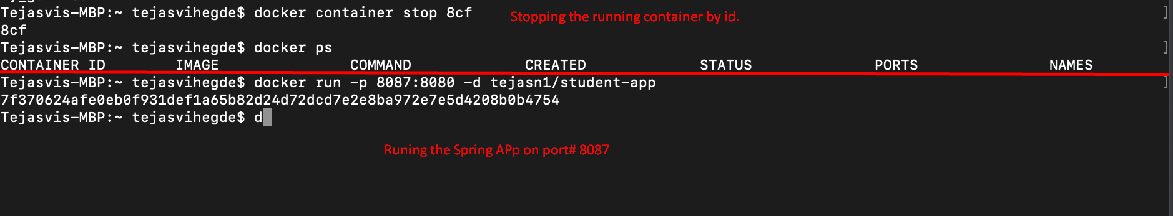  
   **NOTE**: Still app is running on 8080 inside docker container but we changed the mapping of external port now on 8087.   
   Because we access the app from the host machine.